Small Report – UNET Model

1, The transformation usage:

Data Agumentation:

2, Architecture ResNet18 + Unet:

Instead of using decoder blocks at first, I use resnet18 + unet for trainning this model. This can improve segmentation tasks more efficiently.

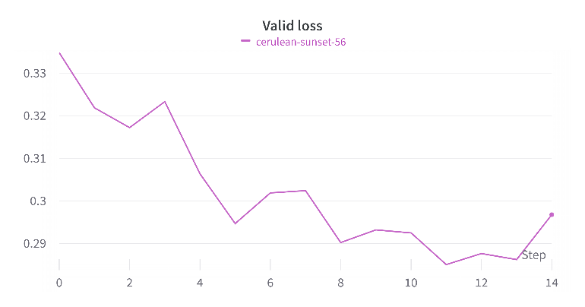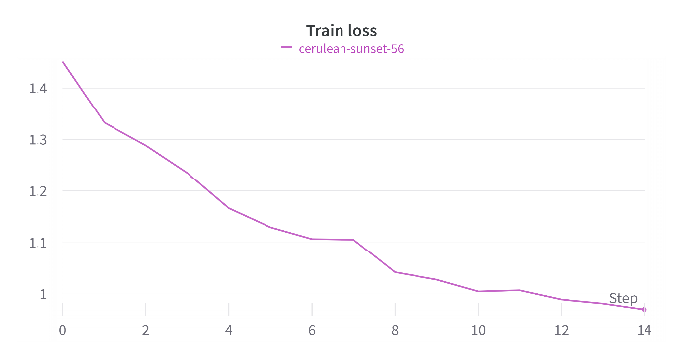3, Train loss and valid loss depiction:

4, Link github repository: https://github.com/VTMinh-20210597/Deep-Learning-Assignment-3.git